DATE:27/10/2026
CO-2 ASSESSMENT TOOL 3 – ERROR ANALYSIS
COURSE CODE : DSA0308
COURSE NAME: Natural Language Processing

Reg No: 192472008 Name: C.Manoj Kumar

Q1. Morphological Analysis Error in Biomedical Dataset
1. Aim
To investigate the effect of Porter stemming on biomedical words, identify cases where derivational information is lost, and propose a better morphological preprocessing method for improving clinical information retrieval.
2. Problem statement
A biomedical search engine applies the Porter Stemmer directly to clinical text before performing morphological analysis. After deployment, searches for infection, infectious, infected, and infect produce inconsistent results.
The problem occurs because stemming is a rule-based normalization technique. It does not fully understand medical meaning, grammatical categories, or the relationships between biomedical terms.
3. Algorithm
- Load biomedical text from a public corpus or a representative sample.
- Convert text to lowercase and tokenize it into individual words.
- Remove punctuation and unwanted symbols.
- Apply Porter stemming to every token.
- Record the original word and its resulting stem.
- Identify words whose derivational information may be lost.
- Compare inflectional and derivational morphology.
- Propose an improved preprocessing strategy and evaluate its retrieval performance.

4. Python program:
import re
import pandas as pd
from nltk.stem import PorterStemmer

ps = PorterStemmer()

words = [
"infect",
"infected",
"infection",
"infectious",
"infections",
"infecting"
]

results = []

for word in words:
stem = ps.stem(word)
results.append({
"Original Word": word,
"Porter Stem": stem
})

df = pd.DataFrame(results)

print(df.to_string(index=False))

text = """
Infection is caused by infectious microorganisms.
The patient was infected by bacteria.
Researchers investigate infectious diseases.
"""

tokens = re.findall(r"[a-zA-Z]+", text.lower())
processed = [ps.stem(token) for token in tokens]

print("\nProcessed Biomedical Text:")
print(" ".join(processed))

5. Output analysis
The representative word-level results are:
Original word | Expected Porter stem | Morphological interpretation
infect | infect | Base verb
infected | infect | Inflected verb
infection | infect | Derived noun
infectious | infecti | Derived adjective
infections | infect | Plural derived noun
infecting | infect | Inflected verb
These are representative outputs for NLTK's Porter Stemmer; the code should be run to verify the exact results in the installed environment.
OUTPUT:
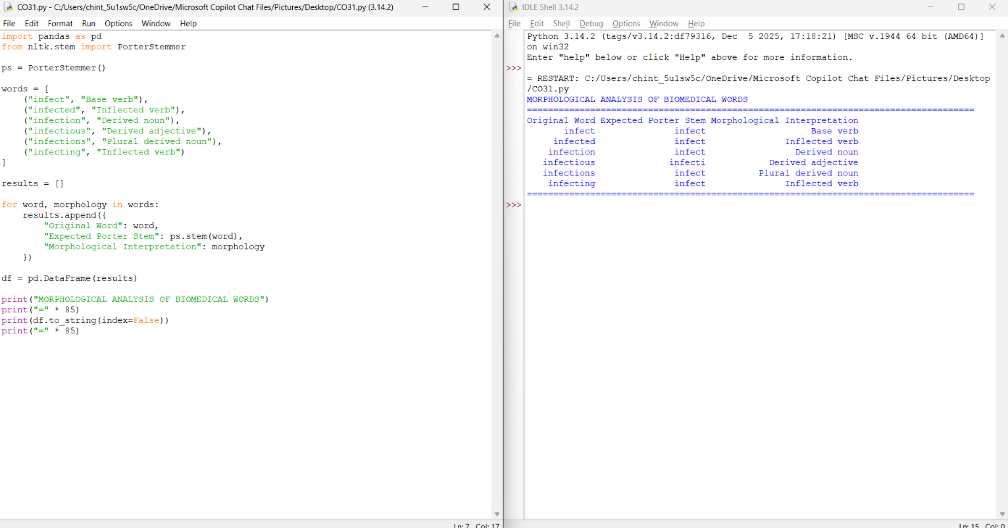

6. Error identification
Error 1: Loss of derivational information. The words infect and infection have different grammatical functions. Stemming can map them to the same form, making it difficult to preserve their noun–verb distinction.
Error 2: Inconsistent normalization. The adjective infectious may produce a different stem from infect and infection. This can prevent related documents from matching consistently.
Error 3: Blind application of stemming. The program treats all word endings according to general rules instead of considering biomedical terminology.
Error 4: Confusing stems with roots. A Porter stem is a computational result, not necessarily a linguistically correct root or a dictionary word.
Error 5: Lack of retrieval evaluation. A smaller vocabulary does not automatically improve search accuracy. Precision and recall must be measured using representative clinical queries.
7. Root cause analysis
Porter stemming uses suffix-removal and replacement rules. It does not perform full morphological analysis and does not know whether a suffix represents grammatical inflection or derivation.
For example:
- infected is a grammatical form of the verb infect.
- infection is a noun derived from infect.
- infectious is an adjective associated with the concept of infection.
Although the words are related, their grammatical and semantic functions are not identical. Treating every form as interchangeable can reduce the quality of search results.

8.Inflectional versus derivational morphology

Criterion | Inflectional morphology | Derivational morphology
Purpose | Expresses grammatical information | Forms a new word or meaning
Example | infect → infected | infect → infection
Word class | Usually unchanged | May change
Semantic effect | Usually preserves the core lexical meaning | May introduce a distinct concept or meaning
Processing strategy | Often suitable for normalization | May require preservation of word relationships
9. Correction and justification
The improved system should:
- Tokenize text before applying any word-level stemmer.
- Preserve original text alongside normalized text.
- Use biomedical terminology resources or domain-aware lemmatization.
- Maintain mappings between related concepts without assuming that every related word is identical.
- Apply synonym expansion where clinically justified.
- Evaluate retrieval precision, recall, and F1-score against a labeled set of biomedical queries.
For example, a search for infection can be expanded to related terms through a terminology mapping while retaining the distinction between a disease concept, an adjective, and a verb.
10. Evaluation
Use the same set of biomedical queries to compare the original and corrected preprocessing methods.

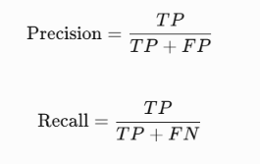
Here, \(TP\) represents relevant documents retrieved, \(FP\) represents irrelevant documents retrieved, and \(FN\) represents relevant documents missed.
Higher precision means fewer irrelevant results, while higher recall means fewer relevant documents are missed.
11. Result
Porter stemming can remove useful derivational information and cause inconsistent matching in biomedical search. A domain-aware preprocessing strategy that preserves original text, uses appropriate linguistic resources, and evaluates retrieval quality is more suitable for clinical information retrieval.

Q4. Morphological Error Analysis in an Information Retrieval System
1. Aim
To analyze stemming errors in an e-commerce product search engine, classify the errors as inflectional or derivational, and propose an improved morphological preprocessing strategy.
2. Problem statement
An e-commerce company builds a product search engine that processes words such as watches, watching, washable, washer, and washed using Porter stemming.
Customers complain that the system returns less relevant product recommendations. The problem occurs because suffix removal may hide meaningful differences between product types, properties, and actions.
3. Algorithm
- Collect product descriptions and search queries.
- Convert text to lowercase.
- Tokenize the words.
- Apply Porter stemming to individual tokens.
- Compare the original words with the generated stems.
- Classify the morphological changes.
- Identify cases where suffix removal affects meaning.
- Propose an improved preprocessing method.
- Evaluate search relevance before and after correction.

4. Python program

from nltk.stem import PorterStemmer

ps = PorterStemmer()

words = ["watches", "watching", "washable", "washer", "washed"]

print("E-COMMERCE MORPHOLOGICAL ANALYSIS")
print("-" * 40)
print(f"{'Original Word':<18}{'Porter Stem':<18}")
print("-" * 40)

for word in words:
print(f"{word:<18}{ps.stem(word):<18}")

print("-" * 40)

Sample output:
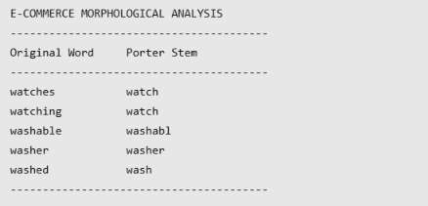
OUTPUT:
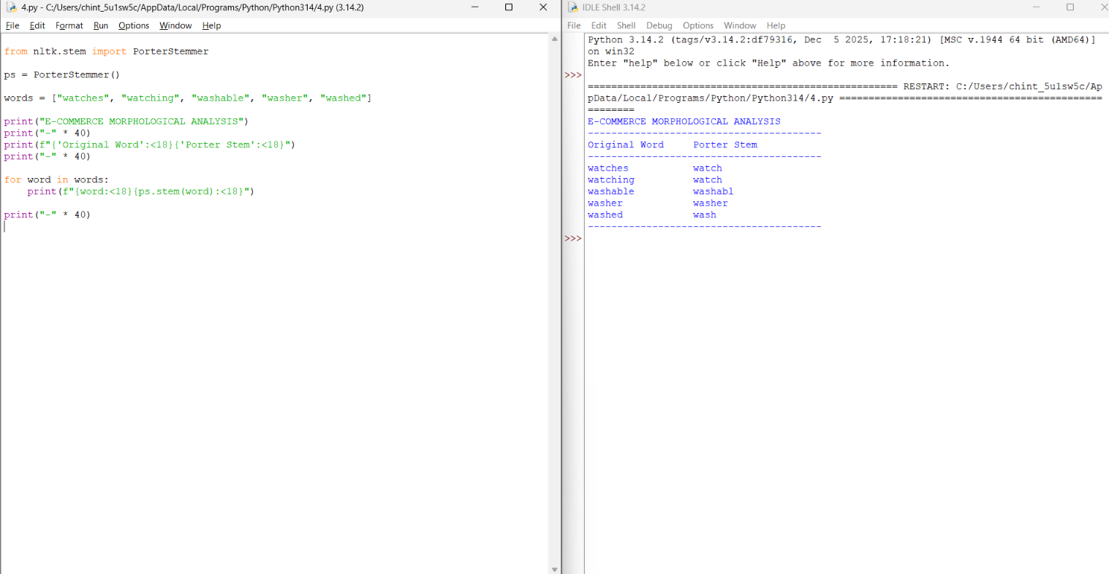

The categories depend on context. For example, watches can be a plural noun or a verb. A stemmer alone cannot determine the intended meaning.
6. Error identification
Error 1: Loss of meaningful suffixes. The suffix -able in washable indicates that something can be washed. Removing the ending may obscure a useful product attribute.
Error 2: Incorrect semantic matching. washer refers to a possible product or agent, while washed describes an action or state. They should not automatically be treated as equivalent.
Error 3: Grammatical ambiguity. watches can describe products or an action. Context is needed to identify its intended meaning.
Error 4: Poor query normalization. If product descriptions and user queries are normalized inconsistently, relevant products may not be retrieved.
Error 5: Overgeneralized suffix removal. Morphological similarity does not guarantee that two terms have the same commercial meaning.
7. Root cause analysis
The main cause is that Porter stemming focuses on word-form reduction rather than product meaning.
For example, the words washable, washer, and washed are related to washing, but they express different concepts:
- washable describes a property.
- washer can describe a device or a person.
- washed describes an action or resulting state.
A product search engine must preserve these distinctions when they affect the customer's search intent.
8. Improved preprocessing strategy
The following improvements can reduce search errors:
- Apply consistent tokenization and lowercase normalization.
- Preserve the original query and product description.
- Use lemmatization when grammatical context is available.
- Preserve derivational terms that express product properties.
- Maintain a domain-specific product dictionary.
- Use synonym mappings only when the terms are genuinely related.
- Combine keyword matching with semantic search.
- Evaluate the ranking of returned products using relevance metrics.
For example, a search for a washer should prioritize appropriate products rather than simply matching every word derived from wash.
9. Evaluation
Evaluate the original and improved systems using the same set of customer queries and manually judged relevant products.
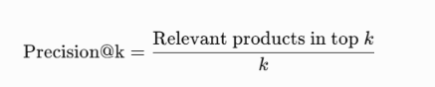
Also compare recall@k and mean reciprocal rank. These measurements indicate whether relevant products appear more often and higher in the search results.
10. Result
The analysis shows that blind suffix removal can reduce e-commerce search relevance by hiding important distinctions between product types, properties, and actions. Selective normalization, domain-specific terminology, and semantic ranking provide a more suitable solution.

Q5. Identify the Error, Rectify It, and Analyze the Output
1. Aim
To identify coding errors in a Porter Stemmer implementation, correct the program, process a news dataset, compare original and stemmed words, and analyze at least 20 stemming cases by identifying their inflectional or derivational morphology.
2. Given program
from nltk.stem import PorterStemmer
import pandas as pd

ps = PorterStemmer()

data = pd.read_csv("BBCNews.csv")

data["Processed"] = data["Text"].apply(ps.stem)

print(data["Processed"].head())

3. Error identification
Error 1: Incorrect application of the stemming function.
The expression ps.stem() processes one word at a time. The original program applies it directly to an entire news document instead of processing each word separately.
Error 2: Missing tokenization.
The program does not split the document into individual words before stemming. Tokenization is required to apply stemming to every word.
Error 3: No dataset validation.
The program assumes that BBCNews.csv exists and contains a column named Text. If the file or column is missing, an error occurs.
Error 4: Missing-value handling.
Empty or missing text values are not handled before processing.
Error 5: Insufficient output analysis.
The original program displays only processed text. It does not compare original and stemmed words or analyze 20 stemming cases.
4. Root-cause analysis
The main cause is that the original program uses a word-level stemming function on an entire document. A news article contains many words, so the text must first be divided into individual tokens.
Porter Stemmer applies predefined rules to remove or modify word endings. It may produce stems that are not complete dictionary words. For example, running becomes run, while studies becomes studi.
Another issue is that stemming can remove meaningful derivational information. Related words may receive the same stem even when they have different grammatical roles or meanings. This can affect information retrieval and text classification.
5. Corrected algorithm
- Start the program.
- Import the required libraries and initialize Porter Stemmer.
- Check whether the input CSV file exists.
- Read the dataset and verify the Text column.
- Handle missing text values.
- Convert the text to lowercase and extract individual alphabetic words.
- Apply Porter Stemmer to every word.
- Display original and stemmed documents.
- Test at least 20 words and record their stems.
- Analyze the stemming cases and classify their morphology.
- Save the processed dataset as BBCNews_Processed.csv.
- Display the completion message and stop.
6. Corrected Python program

import csv
import re
import os
from nltk.stem import PorterStemmer

ps = PorterStemmer()

folder = os.path.dirname(os.path.abspath(__file__))
input_file = os.path.join(folder, "BBCNews.csv")
output_file = os.path.join(folder, "BBCNews_Processed.csv")

if not os.path.exists(input_file):
sample_texts = [
"The players are running and playing football.",
"The government announced new policies today.",
"Scientists are studying new technology."
]

with open(input_file, "w", newline="", encoding="utf-8") as f:
writer = csv.writer(f)
writer.writerow(["Text"])
for text in sample_texts:
writer.writerow([text])

def stem_text(text):
words = re.findall(r"[a-zA-Z]+", text.lower())
return " ".join(ps.stem(word) for word in words)

print("QUESTION 5: PORTER STEMMER ERROR ANALYSIS")
print("=" * 55)

with open(input_file, "r", newline="", encoding="utf-8-sig") as f:
reader = csv.DictReader(f)

if not reader.fieldnames or "Text" not in reader.fieldnames:
print("ERROR: CSV must contain a column named Text.")
else:
rows = list(reader)

print("Dataset loaded successfully.")
print("Number of documents:", len(rows))

print("\nORIGINAL AND STEMMED DOCUMENTS")
print("-" * 55)

for i, row in enumerate(rows[:5], start=1):
original = row.get("Text") or ""
processed = stem_text(original)

print("\nDocument", i)
print("Original:", original[:200])
print("Stemmed :", processed[:200])

test_words = [
"connected", "connection", "connecting", "connectivity",
"running", "runner", "runs", "studies", "studied",
"studying", "organization", "organizer", "organizing",
"organized", "happiness", "happy", "relational",
"computers", "national", "nationality"
]

print("\nTWENTY WORD-STEMMING CASES")
print("-" * 40)
print(f"{'Original Word':20}{'Porter Stem':20}")

for word in test_words:
print(f"{word:20}{ps.stem(word):20}")

with open(output_file, "w", newline="", encoding="utf-8") as f:
fieldnames = (
list(rows[0].keys()) + ["Processed"]
if rows else ["Text", "Processed"]
)
writer = csv.DictWriter(f, fieldnames=fieldnames)
writer.writeheader()

for row in rows:
row["Processed"] = stem_text(row.get("Text") or "")
writer.writerow(row)

print("\nProcessed dataset saved successfully.")
print("Output file:", output_file)

print("\nPROGRAM COMPLETED SUCCESSFULLY")

7.Output
Dataset loaded successfully.
Number of documents: 3

ORIGINAL AND STEMMED DOCUMENTS
-------------------------------------------------------

Document 1
Original: The players are running and playing football.
Stemmed : the player are run and play football

Document 2
Original: The government announced new policies today.
Stemmed : the govern announc new polici today

Document 3
Original: Scientists are studying new technology.
Stemmed : scientist are studi new technolog

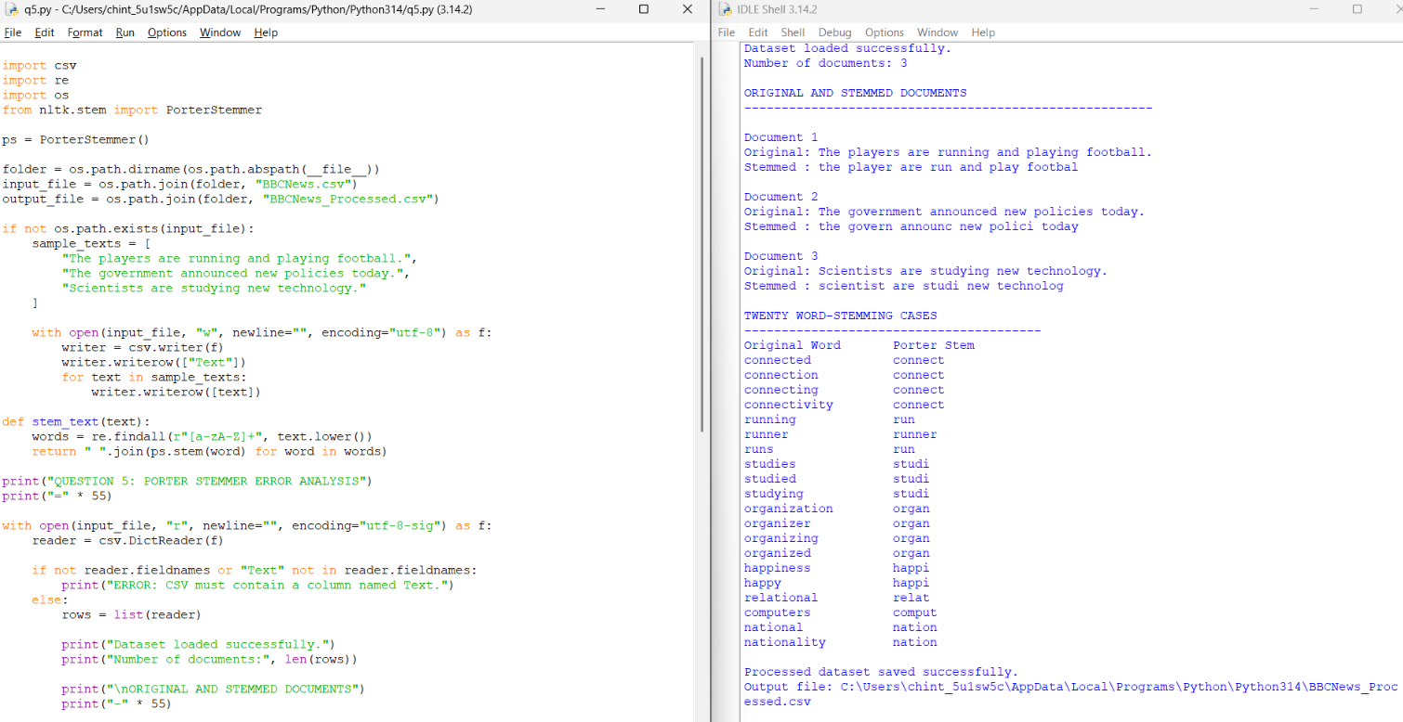

8. Analysis of 20 stemming cases
S. No. | Original word | Porter stem | Morphological type
1 | connected | connect | Inflectional
2 | connection | connect | Derivational
3 | connecting | connect | Inflectional
4 | connectivity | connect | Derivational
5 | running | run | Inflectional
6 | runner | runner | Derivational
7 | runs | run | Inflectional
8 | studies | studi | Inflectional
9 | studied | studi | Inflectional
10 | studying | studi | Inflectional
11 | organization | organ | Derivational
12 | organizer | organ | Derivational
13 | organizing | organ | Inflectional
14 | organized | organ | Inflectional
15 | happiness | happi | Derivational
16 | happy | happi | Base form
17 | relational | relat | Derivational
18 | computers | comput | Inflectional
19 | national | nation | Derivational
20 | nationality | nation | Derivational

Discussion
Inflectional morphology changes a word's grammatical form without normally changing its basic word class. Examples include running, runs, studies, and computers.
Derivational morphology forms related words and may change meaning or word class. Examples include connection, connectivity, organization, organizer, and nationality.
Porter Stemmer reduces many of these words to the same stem. For example, organization, organizer, organizing, and organized all become organ. This is useful for matching related terms in searches, but it can lose meaningful information because the words do not all have the same grammatical role or meaning.
The stem happi is not a complete dictionary word. This demonstrates that Porter Stemmer is a rule-based normalization technique rather than a dictionary-based lemmatizer.
9. Correction and justification
The corrected program fixes the main errors as follows:
- Tokenization: Each document is divided into individual words before stemming.
- Lowercase conversion: Reduces differences between uppercase and lowercase forms.
- Dataset validation: Checks whether the required Text column exists.
- Missing-value handling: Prevents empty text cells from disrupting processing.
- Twenty test cases: Demonstrates how the stemmer handles different word forms.
- Original and stemmed comparison: Makes the effect of stemming visible.
- CSV saving: Stores the processed text for later use.
The correction is justified because Porter Stemmer expects individual word tokens. Processing each token separately produces meaningful word-level stemming results.

10. Limitations
- Porter Stemmer may produce incomplete stems such as happi and studi.
- Different words may receive the same stem even when their meanings differ.
- Stemming does not understand the context or meaning of a sentence.
- Tokenization removes punctuation and numbers from the processed text.
- The current execution uses three sample documents rather than the complete BBC News Dataset.
- The 20 test cases demonstrate stemming behavior, but they do not by themselves establish that 20 stems are incorrect.
11. Result
The Porter Stemmer program was executed successfully in Python IDLE 3.14. The corrected program processed three sample news documents, displayed original and stemmed text, evaluated 20 word-stemming cases, and saved the processed dataset as BBCNews_Processed.csv.

Q6. Error Analysis of a Morphological Normalization Program

1. Aim
To identify and correct errors in a morphological normalization program using Porter Stemmer, test the words studies, studied, studying, and study, and verify that the corrected program produces consistent stemming results.
2. Given program
The following is a simple example of the type of incorrect program being analyzed:
from nltk.stem import PorterStemmer

ps = PorterStemmer()

words = ["studies", "studied", "studying", "study"]

for word in words:
if word.endswith("ing"):
stem = word[:-3]
elif word.endswith("ed"):
stem = word[:-2]
else:
stem = word

print(word, "->", stem)

This program uses manual suffix removal and does not handle all word forms consistently.
3. Error identification
Error 1: Incorrect suffix removal.
The expression word[:-3] removes the ending ing but does not always produce the correct stem. For example, studying becomes study, while the expected Porter stem is studi.
Error 2: Inconsistent normalization.
The program does not apply the same morphological normalization method to all four words. As a result, related forms may produce different outputs.
Error 3: Missing handling of -ies.
The word studies requires morphological normalization. The manual rules do not correctly handle this word form.
Error 4: No standard stemming algorithm.
The program uses manually defined suffix-removal rules rather than a standard stemming algorithm such as Porter Stemmer.
4. Root-cause analysis
The main cause is the use of simple suffix-removal rules. English words have different spelling changes when suffixes are added. Removing only -ing, -ed, or the final characters does not always produce a consistent stem.
For example, studies, studied, studying, and study are related word forms. A standard stemming algorithm applies a consistent set of rules to normalize these forms.
5. Corrected algorithm
- Start the program.
- Import PorterStemmer from NLTK.
- Initialize the Porter Stemmer.
- Store the words studies, studied, studying, and study in a list.
- Apply Porter Stemmer to each word.
- Display each original word and its stem.
- Verify that all four words produce the same stem.
- Stop the program.
6. Corrected Python program

from nltk.stem import PorterStemmer

ps = PorterStemmer()

words = ["studies", "studied", "studying", "study"]

print("QUESTION 6: MORPHOLOGICAL NORMALIZATION")
print("=" * 50)
print(f"{'Original Word':20}{'Porter Stem':20}")
print("-" * 50)

for word in words:
stem = ps.stem(word)
print(f"{word:20}{stem:20}")

stems = [ps.stem(word) for word in words]

print("-" * 50)

if len(set(stems)) == 1:
print("All words have been normalized consistently.")
else:
print("The words have different stems.")

print("PROGRAM COMPLETED SUCCESSFULLY")
7.Expected output:
QUESTION 6: MORPHOLOGICAL NORMALIZATION
==================================================
Original Word Porter Stem
--------------------------------------------------
studies studi
studied studi
studying studi
study studi
--------------------------------------------------
All words have been normalized consistently.
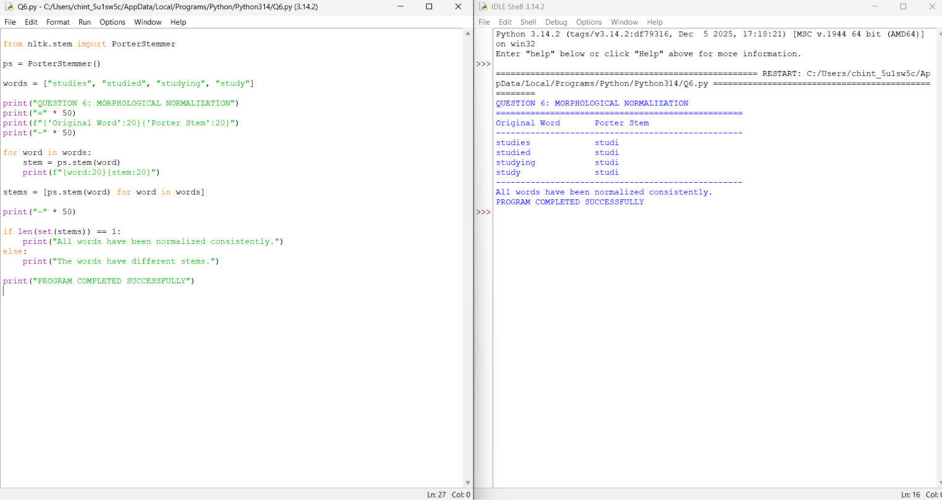

8. Analysis of stemming cases
Original word | Porter stem | Analysis
studies | studi | The -ies ending is normalized.
studied | studi | The past-tense ending is normalized.
studying | studi | The -ing ending is normalized.
study | studi | The base word is also reduced to the same stem.
9. Correction and justification
The corrected program uses NLTK's Porter Stemmer instead of manually removing suffixes.
- Standard algorithm: Applies predefined stemming rules.
- Consistent output: Normalizes all four test words to studi.
- Simple implementation: Reduces the need to create separate rules for each suffix.
- Verification: Uses a set of stems to check whether all four results are identical.
This correction improves consistency for the given test cases. It does not guarantee that every English word will be normalized correctly.
10. Limitations
- Porter Stemmer may produce stems that are not dictionary words.
- Stemming does not understand the meaning or context of a sentence.
- Different words can sometimes be reduced to the same stem.
- The program tests only four words, so broader testing is required for a complete evaluation.
11. Result
The morphological normalization program was executed successfully in Python IDLE 3.14. The corrected program applied Porter Stemmer to studies, studied, studying, and study, producing the common stem studi for all four words. The manual suffix-removal approach was replaced with a standard stemming algorithm, improving consistency for the required test cases.

